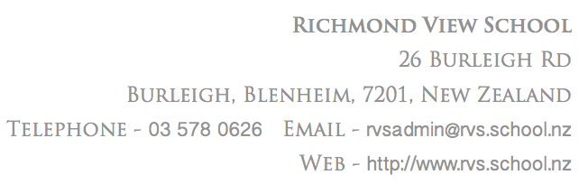

Important Points:

* Please return form to classroom teacher by Friday 12th May.

.

1st May 2017

Senior Camp, Mistletoe Bay. Term 4 2017

Dear parents

We are sure that your son or daughter has already shared the exciting news about the Mistletoe Bay camp later in the year and which also includes Year 6 students for the first time. The dates of the camp are as follows -

Tuesday 28th November – Friday 1st December (3 nights) Year 7 and 8 students.

Tuesday 28th November – Thursday 30th November (2 nights) year 6 students.

Although the dates are towards the end of the year planning has already begun. To help us with this   
it would be beneficial to have an indication of how parents may be able to assist. We completely understand that people’s plans and commitments may change before November, but we would appreciate it if you could offer a tentative indication of how you may be able to help. We would obviously confirm with you nearer the time if you still are able, or requested, to help.

Please would you complete and return the slip below to the classroom teacher by Friday 12th May.

Thank you so much for your assistance with this. Camp is already looking like it’s going to be an awesome experience for the students.

Kind regards

Shaun Freeman and Carol Wilson

□ I am unable to help.

□ I may be available to transport to Picton on Tuesday 28th November before 9am.

□ I may be available to transport back from Picton on Thursday 30th at 12.45pm

□ I may be available to transport back from Picton on Friday 1st December at 12.45pm

□ I may be available to be a parent helper on camp.

Parent Name___________________________________________

Contact Number________________________________________

